

**Faculty of Computer Science and Information Technology**

**Department of Software Engineering**

**SSE4353 Component-Based Software Development**

**Semester 2 2019/2020**

**Report Group Project  
Project Name: Event Management System.**

**Class Group** **: 1**

**Prepared for** **: Dr. Novia Indriaty Admodisastro**

**Prepared by :**

|  |  |
| --- | --- |
| **Name** | **Matric Number** |
| **Loo Yiyang** | **192458** |
| **Chai Qiang Yuan** | **194696** |
| **Tan Yi Min** | **192629** |
| **Siti Nur Syahirah Bt Mohd Ashri** | **193578** |

Table of Contents

1.0 Project Background 3

1.1 Purpose 3

1.2 Scope 3

1.3 Objective 3

2.0 System Analysis 4

2.1 User Class and Characteristics 4

2.2 Functional Requirements 5

2.3 Non-Functional Requirements 6

2.4 Use Case Diagram 7

3.0 UI Design 8

3.1 User’s view 8

3.2 Admin’s view 13

4.0 System Design 17

4.1 Development View 17

4.2 Physical View 18

4.3 Logical View 18

5.0 Component Descriptions 19

6.0 Descriptions of API and Third-Party Components 19

# Project Background

## 1.1 Purpose

The web application solution to be developed using the Java EE Framework for this group project is Event Management System (EVT). Event management is a web platform system of project management to create and develop large scale events such as festivals, conferences, competitions, ceremonies, formal parties, concerts, conventions and more. Event management systems provide many advantages over the traditional event management methods due to their efficiency and cost. It helps to create, develop and manage events easily. The limitations of the current system are not widely used and known to users. It is because the created event only sends email to the participating audience. It also provides a basic function of the event management system for creating and searching events for one user interaction only. Meanwhile EVT provides three user interactions including students, lecturers and admin within FSKTM faculty.

## Scope

The Event Management System (EVT) is a system that will manage all the events that are organized in the Faculty of Computer Science and Information Technology (FSKTM), University Putra Malaysia (UPM). It is created to target users such as students, lecturers and admin. In the system, there are two types of users involved which content different features, roles and responsibilities. The first user is for students and lecturers who have desired to view and join the events that will be organized at the faculty. Meanwhile, the next user is admin who are the staff that are responsible to manage all the events every time they are created.

## Objective

* To ease the process of managing all the events that are conducted in FKSTM, UPM by admin.
* To view the events that will be conducted in FKSTM, UPM by users.
* To participate in the events that will be conducted in FKSTM, UPM by users.
* To allow users to book a ticket online for the events.

2.0 System Analysis

This section will describe on functional and non-functional requirements of the proposed system. The requirements are consists of stakeholders as mentioned below:

1. User (Students and lecturers of FSKTM).
2. System admin of Event Management System.

## 2.1 User Class and Characteristics

|  |  |
| --- | --- |
| **Actor** | **Roles** |
| User (Students, Lecturers) | * Register account * Login account * Update profile * Join event * Book ticket for a specific event * Check ticket for a participated event * Delete ticket for a participated event |
| System admin | * Login account * Manage all the registered event * Add new event * Edit registered event * Delete registered event * View participants list |

## 2.2 Functional Requirements

This subsection is used to briefly describe the system use cases.

|  |  |  |
| --- | --- | --- |
| **Identifier** | **Use Cases** | **Description of Use Cases** |
| UC1.0 | Register | Users shall be able to register for a new account if they are first-time users. |
| UC2.0 | Login | Users/Admin shall be able to login to the proposed system by using specific ID and password. |
| UC3.0 | Update Users’ Profile | Users shall be able to update their profile to the latest information. |
| UC4.0 | Join Events | Users shall be able to join events posted by the admin. |
| UC4.1 | Book Tickets | Users shall be able to book tickets for the events that they are interested in. |
| UC4.2 | Check Tickets | Users shall be able to check the tickets that have been booked to confirm the event’s information. |
| UC4.3 | Delete Tickets | Users shall be able to delete the tickets that have been booked if they regret joining the events. |
| UC5.0 | Manage Events | Admin shall be able to manage events. |
| UC5.1 | Add Events | Admin shall be able to add new events. |
| UC5.2 | Edit Events | Admin shall be able to edit registered events’ information. |
| UC5.3 | View Participants’ List | Admin shall be able to view participants' lists in certain events. |

Table 1: Use cases and descriptions

## 2.3 Non-Functional Requirements

**NFR01 - Performance Requirements**

Event Management System is expected to have reasonably short response time. Users such as students and lecturers shall be able to access from page to page within 3 seconds. The system is expected to serve a maximum number of 500 users at one time and able to operate when users choose to join specific events simultaneously.

**NFR02 - Security Requirements**

Event Management System shall be able to authenticate the students’ and lecturers’ identity as a user to access the system by verifying their unique user ID and password. All the passwords registered by users must store as encrypted form in database to maintain confidentiality of personal information.

**NFR03 - Availability**

Event Management System shall be available for 24 hours except for the maintenance time. Users such as students and lecturers can login at any time to access the events’ information and join the events. The system’s downtime must not more than 2 hours to avoid loss of users’ confidence.

**NFR04 - Usability**

A new user shall be able to register account, search events and join events in less than 10 minutes without user manual needed. Users shall be able to easy get recall on where to search events, join events and check tickets on their subsequent visit without spending too much time.

**NFR05 - Extensibility**

Event Management System shall be able to extend their features by integrating third party components to improve the functionality. For instance, adding calendar and timer components into system to set reminder for the events registered.

**NFR06 - Recoverability**

Event Management System shall be able to restore the system by using protected backup files. Archiving and backing up the data regularly or when unexpected event occurred.

## 2.4 Use Case Diagram

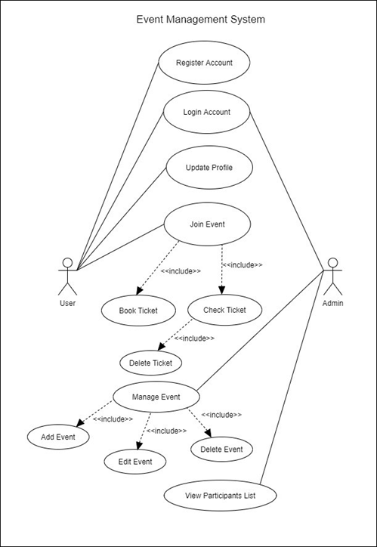

**Figure 2.4: Use Case diagram for Event Management System.**

# 3.0 UI Design

## 3.1 User’s view

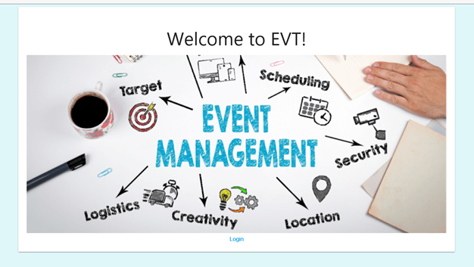

**Figure 3.1.1: Event Management System’s Homepage**

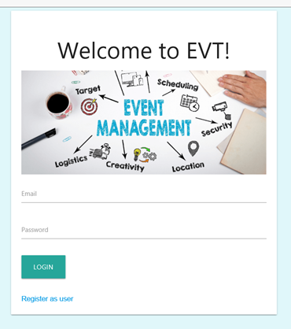

**Figure 3.1.2: Login page**

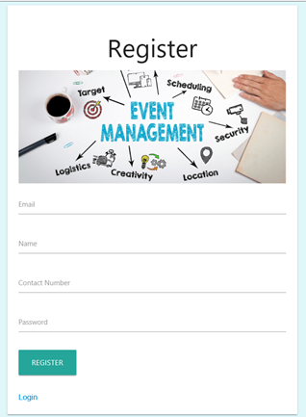

**Figure 3.1.3: User’s registration page**

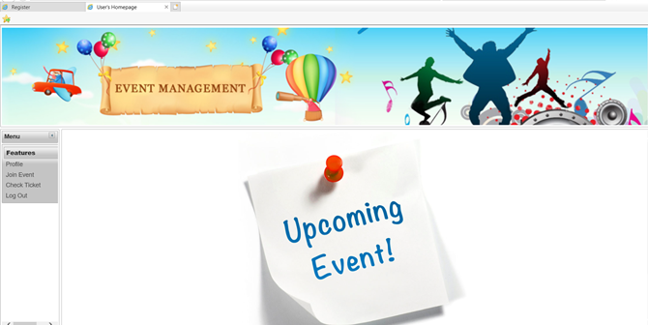

**Figure 3.1.4: User’s homepage**

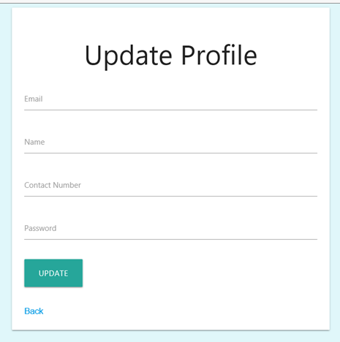

**Figure 3.1.5: User’s profile**

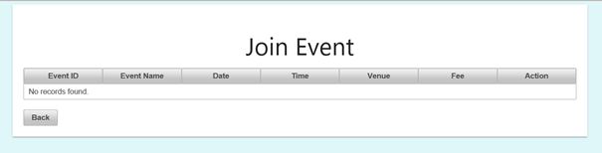**Figure 3.1.6: User join Event page**

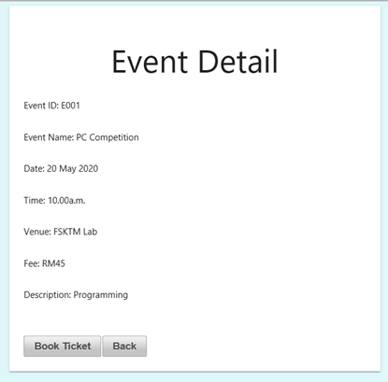

**Figure 3.1.7: User book ticket page**

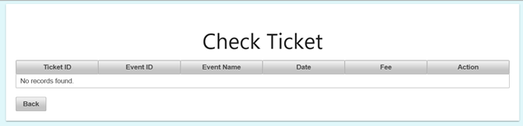

**Figure 3.1.8: User check ticket page**

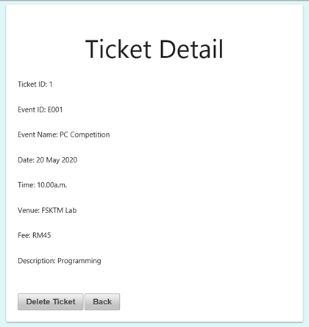

**Figure 3.1.9: Ticket detail page**

## 3.2 Admin’s view

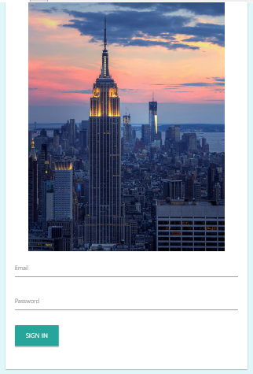

**Figure 3.2.1: Login page**



**Figure 3.2.2: Admin’s homepage**

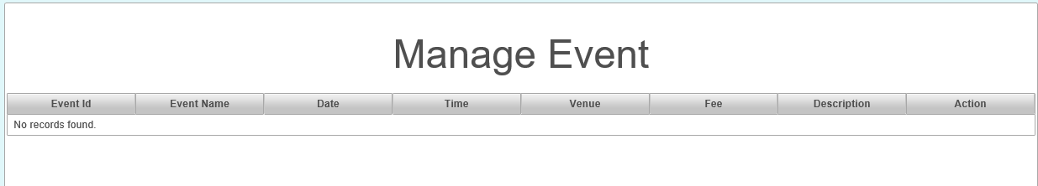

**Figure 3.2.3: Admin manages event page**

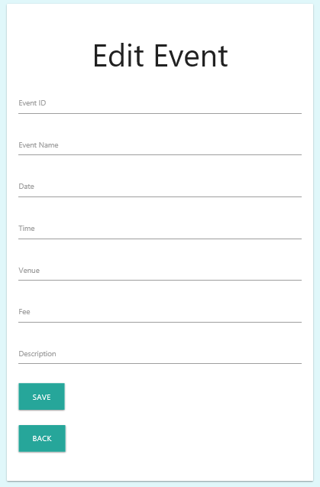

**Figure 3.2.4: Admin edits event page**

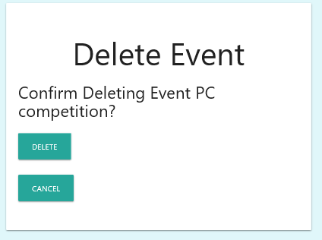

**Figure 3.2.5: Admin deletes event page**

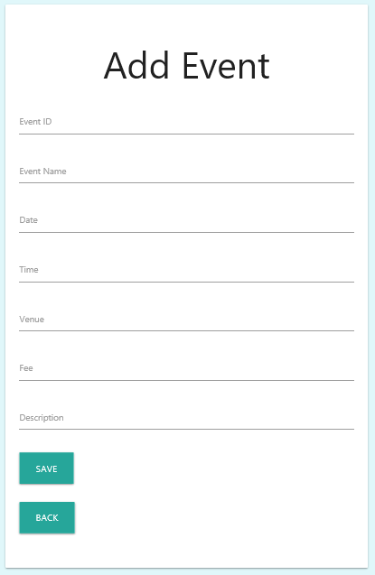

**Figure 3.2.6: Admin add new event page**

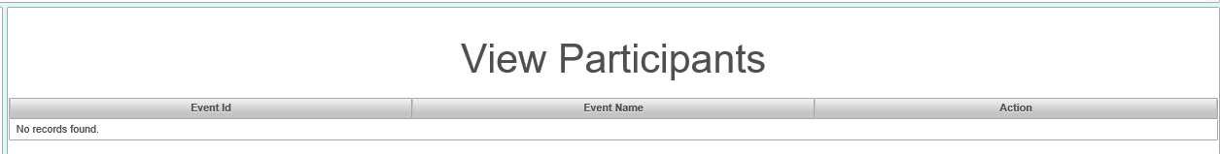

**Figure 3.2.7: Admin views participants page**

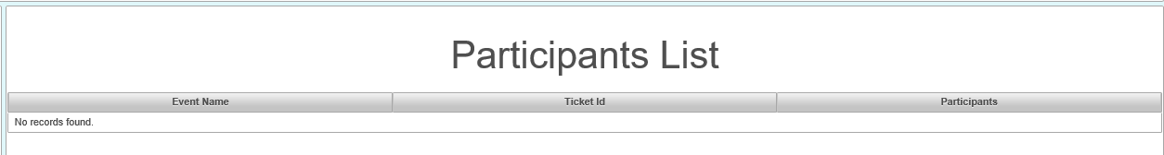

**Figure 3.2.8: Participants’ list page**

# 4.0 System Design

## 4.1 Development View

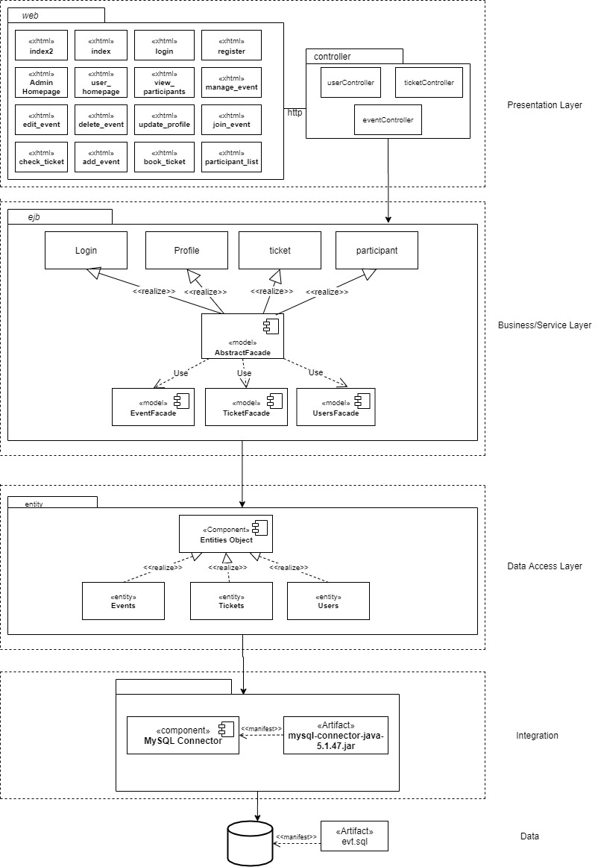  
**Figure 4.1: Component diagram implementing layered architecture.**

## 4.2 Physical View

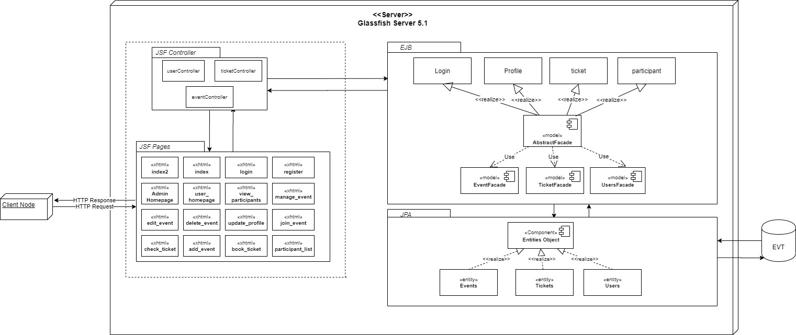

**Figure 4.2: Deployment diagram of Event Management System**

## 4.3 Logical View

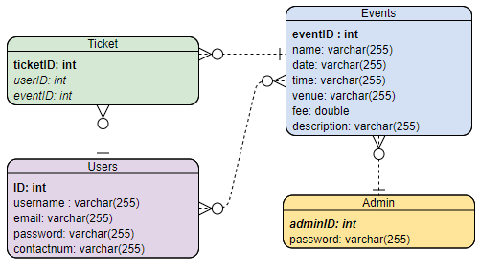

**Figure 4.3: Entity Relationship Diagram (ERD) of Event Management System**

# 5.0 Component Descriptions

|  |  |  |
| --- | --- | --- |
| No. | Component | Description |
| 1. | AbstractFacade | A Stateless session bean that do CRUD operation. |
| 2. | UsersFacade | A Stateless session bean for user entity class. |
| 3. | TicketFacade | A Stateless session bean for ticket entity class. |
| 4. | EventFacade | A Stateless session bean for event entity class. |
| 5 | Entities Object | Java entity classes that map the rDBMS using Java Persistence API (ORM) |

**Table 5.0: Components and their description of EVT**

# 6.0 Descriptions of API and Third-Party Components

|  |  |  |
| --- | --- | --- |
| No. | API/ Third Party Component | Descriptions |
| 1 | MySQL Connector | MySQL provides connectivity for applications developed in the Java programming language with MySQL Connector/J, a driver that implements the Java Database Connectivity (JDBC) API. |